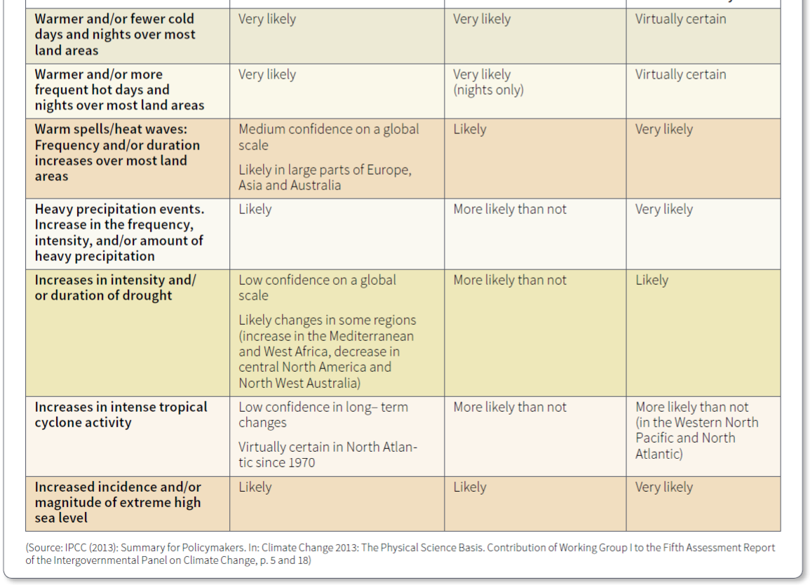
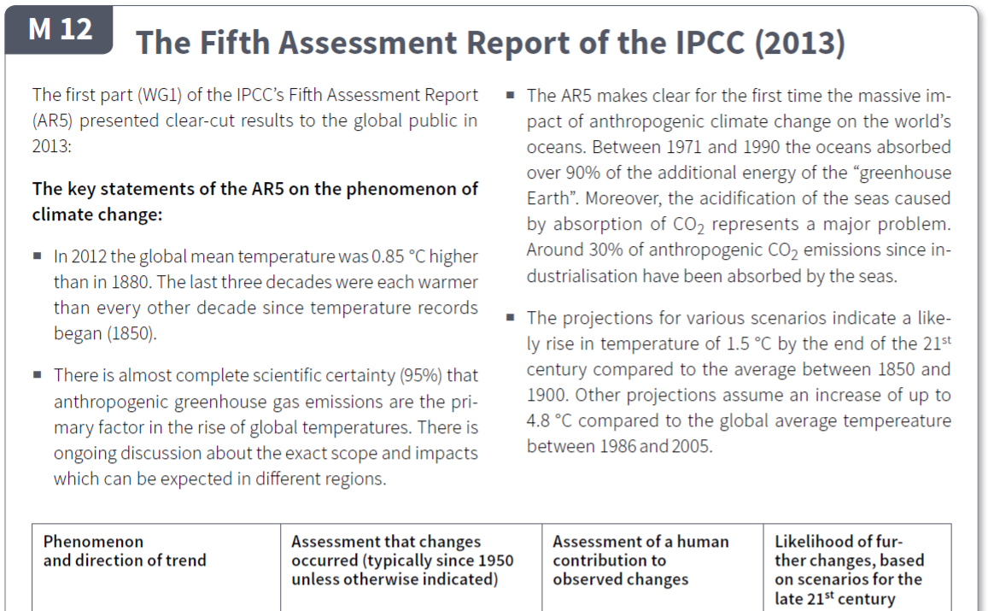
The Consequences of Climate Change
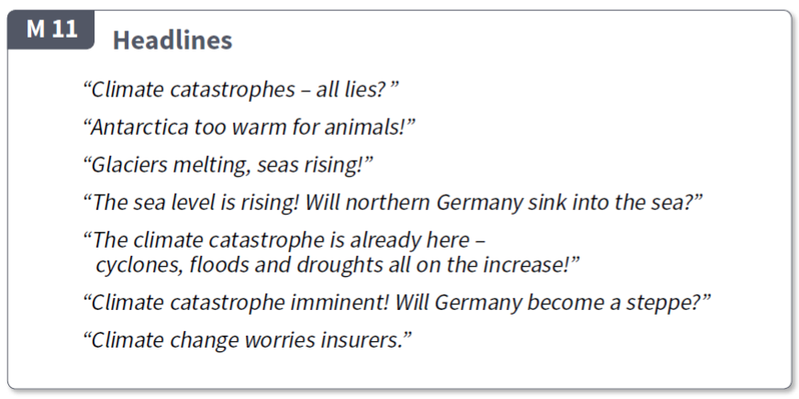
“Climate catastrophes – all lies?”
“Antarctica too warm for animals”
“Glaciers melting, seas rising!”
“The sea level is rising, will Tasmania sink into the sea?”
“The climate catastrophe is already here – cyclones, floods and droughts all on the increase!”
“Climate catastrophe imminent! Will Australia become a desert?”

Questions
- Read the introduction section in M12. It lists four main points made by the International Panel for Climate Change (IPCC) fifth assessment report in 2013. Summarise each of the four points into one sentence each
- _____________________________________________________________________________________
- _____________________________________________________________________________________
- _____________________________________________________________________________________
- _____________________________________________________________________________________

- Read the information in the table in M12. It presents information on whether changes caused by climate change (1st column) have already occurred (column 2), have been caused by humans (column 3), are likely to occur in the future (column 4).
Now read the headlines contained in M11.
Choose any 3 of these headlines and write a short response (2-3 sentences) to each of them. You should reference (use) the information from the table in M12 in your responses
- __________________________________________________________________________________________________________________________________________________________________________________________________________________________________________________________________________________________________________________________________________________________________________
- __________________________________________________________________________________________________________________________________________________________________________________________________________________________________________________________________________________________________________________________________________________________________________
- __________________________________________________________________________________________________________________________________________________________________________________________________________________________________________________________________________________________________________________________________________________________________________

